**ORDER FOOD ONLINE ON ZOMATO**

**Dissertation submitted in partial fulfillment of the**

**requirements for the award of the Course of**

**EXL- Certified Software Test Engineer**

**Submitted By**

**Rijwana S.**

**BATCH : 2022 – 7607**

**ENROLLMENT NUMBER : EBEON0722634378**

**Under the Guidance of**

**MOHANA PRIYA**

**Center Trainer**



**CONTENT**

|  |  |
| --- | --- |
| S.NO | INDEX |
| **1** | INTRODUCTION |
| **2** | SCOPE AND OBJECTIVES |
| **3** | SYSTEM SPECIFICATION |
| **4** | SYSTEM DESIGN |
| **5** | IMPLEMENTATION |
| **6** | SYSTEM TESTING |
| **7** | CONCLUSION |

#### 1:INTRODUCTION

##### 1.1:Project Outline ( Purpose And Goal )

##### **Zomato** is an [Indian](https://en.wikipedia.org/wiki/India) restaurant search and discovery online service (web and app). It is spread worldwide, And is known for its Online food delivery It has also launched Cloud kitchens in many regions across the world, It gathers and provides information of restaurants on a regular basis, it allows food lovers to share their reviews and photos of every restaurant. so that people can make an informed choice.

##### Zomato is one of the most comprehensive and user-friendly apps where people can search for nearby restaurants and cafés, order food online, and get it delivered at their doorstep in no time. Moreover, you can also get accurate information about restaurants as it provides menus, reviews, and ratings. Based on that, users can place orders and enjoy lip-smacking food at their homes.

Every meal matters. Every meal matters. In the summer of 2015, when we were preparing to

launch online food ordering services in India, we had more questions than answers.

Customers use our platform to search and discover restaurants, read and write customer

generated reviews and view and upload photos, order food delivery, book a table and make

payments while dining-out at restaurants.

**2.SCOPE AND OBJECTIVES**

**2.1:SCOPE AND OBJECTIVES**

The Indian internet and e-commerce sector has emerged to be one of the fastest growing sectors of the country, even in the pandemic-hit economy. The Indian start-up ecosystem witnessed 43 companies turn unicorns in 2021; more than 30 odd unicorns that were created till date up to 2020.

Zomato offered a solution by being the bridge between the needs of the consumer and offering scalability/distribution to manufacturers (restaurants).  
  
As we all understand, the gross margins (ex-RM cost) are very high (around 65%-75%) in the food business, but the fixed overhead cost for the restaurant owners also remains heavy. Therefore, for every incremental revenue if the restaurant has to share a certain percentage (15%-25%) with the distribution partner like Zomatoo.

Online restaurant guide and food ordering firm Zomato Monday said it is planning to convert 40 per cent of its delivery fleet into power-assisted bikes in two years.

Currently, the company has over 5,000 cyclists operating across 12 cities in India, with the majority of the fleet being in Delhi-NCR, Zomato said in a statement.

The company provides food delivery services in 150 cities across the country with a last-mile delivery fleet of 1.5 lakh partners, it added.

"We are working closely with our vendor partners to raise the scale of e-cycle adoption and aim to convert 40 per cent of our fleet to power-assisted bikes within the next two years," Zomato Food Delivery business CEO Mohit Gupta said.

## **2.2:Benefits of online ordering-**

### 1. An improved customer experience

When the ordering process is easy, it increases the likelihood that the customer will complete their order. People want fast, immediate service — which is why the user experience is critical when someone is ready to make a purchase. Customers appreciate not having to sit in their car or the restaurant to wait for their food.

### 2. Streamlined restaurant operations

Online ordering can streamline your systems in the kitchen. When customers send their orders online, it decreases the amount of time staff members need to spend on the phone. Instead, the team can complete the steps — such as cooking the food, packaging it, and delivering it — necessary to ensure that every meal is ready for your customers on time.

### 3. More time to browse the menu

Customers want to know specifics about their food options, which is why it’s smart to list details and descriptions in the online ordering system. Not only does an online menu provide more information about food options, but it allows customers to take the time they need to browse the menu.

### 4. Increased transaction amounts

Since customers have more time to browse the menu online, there’s a greater chance that they’ll add extra items to their order. An additional appetizer or dessert might seem insignificant, but the numbers can add up over time.

### 5. More customer control over orders

When you’re busy during the dinner rush, it’s easy for small order details to slip through the cracks. Your staff doesn’t have a lot of time to spend on phone calls, often resulting in rushed conversations and missed information. One of the benefits of online ordering for restaurants is that customers manage their own orders, which gives them the ability to order exactly what they want — and that includes giving special instructions.

### 6. Easier to place large orders

The likelihood of miscommunication increases when a customer places a large order over the phone. When someone needs a large or complex food order, they will go with the easiest option. Often, people want to avoid ordering over the phone because sharing the full order verbally can be tedious. Online ordering is a simple solution for large orders, helping to decrease the possibility of miscommunication and increase customer satisfaction.

### 7. Being on top of current trends

If you want to stay relevant in the industry, then you need to keep up with the trends. What does it say about your restaurant when you don’t have a website and your competitors are offering online [food ordering](https://www.jotform.com/food-ordering-system/)? You need to stay competitive, which means that you need to be up to date with an online presence and the option for digital orders.

### 8. Fewer abandoned orders

How often do customers place phone orders and never pick up the food? When you have an online ordering system, your restaurant benefits from [online payments](https://www.jotform.com/online-payments/). Customers pay for their food digitally when submitting their order, which reduces the chances of fake or abandoned orders. As a result, you reduce your risk and ensure that you receive payment.

# **3.** **SYSTEM SPECIFICATION**

**3.1:HARDWARE SPECIFICATION**

Processors will continue to get faster, smaller and cheaper, whereas memory will continue to get faster, larger and cheaper. The trend except to have a reasonable memory to a powerful processor.

Processor : 11th Gen Intel(R) Core(TM) i3

Ram : 1GB RAM

Hard Drive : 160 GB

Monitor : 16 INCHES

Keyboard : 104 keys

Mouse : Logitech Optical Mouse

##### 3.2:SOFTWARE SPECIFICATION

When an application project is considered the three basic software requirements are the platform in which the project is developed, the front-end tool that provides the interaction with the users and the back- end tool that stores the data.

Operating System : Windows11

Front-end : Visual Studio, Microsft Edge.

##### 3.3:FEATURES OF LEARNING IN ONLINE SYSTEM

1. Vast choices of Restaurants
2. Order Scheduling
3. Geo-location
4. Rating System
5. Internal Payment System

**4.SYSTEM DESIGN**

**4.1:Use case diagram:-**

The **use case diagram using include and extend** is used to elaborate the proceeding diagrams. The terms include and extend are known as indicators.

This process enables the admin to manage and monitor customers’ information and status. They were able to track the customers’ basic information such as contact numbers and addresses as references for food deliveries.

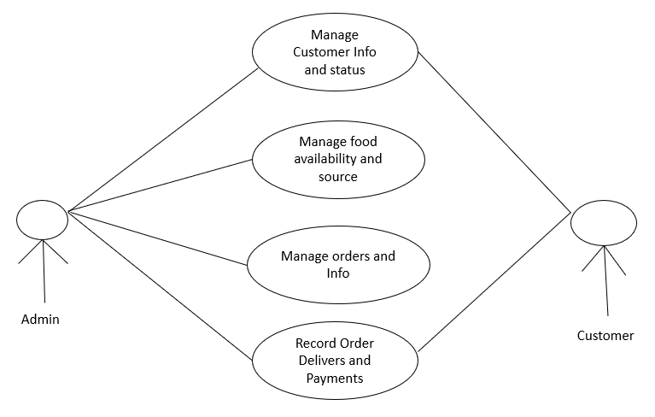

**Fig(1):-Use case daigaram**

**1 Use case Descriptions**

A use case is a methodology used in system analysis to identify, clarify and organize system requirements. The use case is made up of a set of possible sequences of interactions between systems and users in a particular environment and related to a particular goal.

The method creates a document that describes all the steps taken by a user to complete an activity.

|  |  |  |  |
| --- | --- | --- | --- |
| **S.No** | **USECASE** | **ACTOR** | **DESCRIPTION** |
| 1 | Login | Administrator, Student (user) and Visitor. | Enter user name, and password |
| 2 | Registration | Administrator, Student (user) and Visitor. | First name, last name, email id, password. |
| 3 | Contact us | Administrator, Student (user) and Visitor. | First name, last name, email id, password, subject and comment box. |

**4.1.2 Use case Explanations**

In this use case diagram they mention the step process

**4.1.3 Use case 001: login**

INTORDUCTION: this use case outlines the step that need to be followed in order to login into the system.

**Start**

ACTOR: Administrator, Student (user)

PRE-CONDITION: user has to have a valid credential

POST-CONDITION: the system display the relevant page

BASIC FLOW: the user enter the user name and password

**Scenario:**

|  |  |
| --- | --- |
| **ACTOR** | **SOFTWARE REACTION** |
| User name  password | If it is valid user can enter into system  If it is invalid user it indicates it is wrong user name or password |

ALTERNATE FLOW: the user can enter the reg no

SPECIAL REQUIREMENTS: None

ASSOCIATED USE CASE(S): None

**4.1.4 Use case 002: Registration**

INTORDUCTION: this use case outlines the step that need to be followed in order to register form

ACTOR: student (user) and admin.

PRE-CONDITION: user has to have a valid credential

POST-CONDITION: the system display the relevant page

BASIC FLOW: the system confirms that the entered details is correct or not.

|  |  |
| --- | --- |
| **ACTOR** | **SOFTWARE REACTION** |
| First name  Last name  Email id  Password | The system verifies that the above items has been filled out  If any data is missing, the system warns the user and the steps continues with software reaction  If all data has been entered the system ask the user to view the result.  If the user indicate they want to end the scenario here  And If the user indicate that their marks are not correct the scenario continues with software reaction. |

**Scenario:**

ALTERNATE FLOW: None

SPECIAL REQUIREMENTS: None

ASSOCIATED USE CASE(S): None

**4.1.5 Use case 003: Contact us**

INTORDUCTION: this use case outlines the step that need to be followed in order to fill out the data

ACTOR: student (user) and admin

PRE-CONDITION: user has to have a valid credential

POST-CONDITION: the system display the relevant page

BASIC FOLW: the user enter the details

**Scenario:**

|  |  |
| --- | --- |
| **ACTOR** | **SOFTWARE REACTION** |
| First name  Last name  Email id  Password  Subject  Comment | The system verifies that the above items has been filled out  If any data is missing, the system warns the user and the steps continues with software reaction  If all data has been entered the system ask the user to view the result.  If the user indicate they want to end the scenario here  And If the user indicate that their marks are not correct the scenario continues with software reaction. |

ALTERNATE FLOW: click the help option

SPECIAL REQUIREMENTS: None

ASSOCIATED USE CASE(S): None

**4.2:Activity Daigram:-**

The given Activity Diagram for the Online Food Ordering System is here. It shows how the system would interact with the customer and the food stand or restaurant crew. The interactions given here are based on the activities that usually happen in a food order.

1. **Designed Activity Diagram of Online Food Ordering System**

This activity diagram must be created to show you its core function and how does the exchange of actions or activity happens.

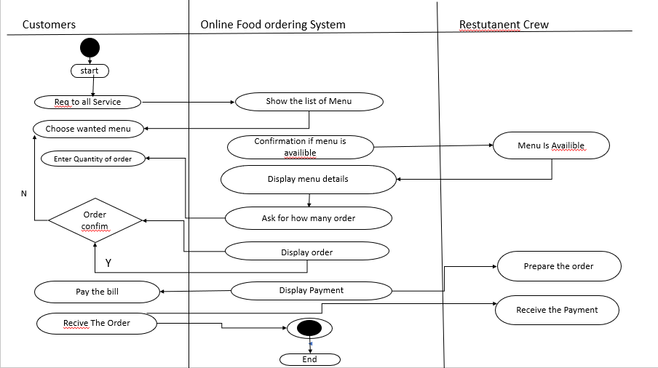

**Fig(2):Activity Daigram**

**4.3:Class Daigram:-**

The given Activity Diagram for the Online Food Ordering System is here. It shows how the system would interact with the customer and the food stand or restaurant crew. The interactions given here are based on the activities that usually happen in a food order.

**Designed Activity Diagram of Online Food Ordering System**

This activity diagram must be created to show you its core function and how does the exchange of actions or activity happens.

As you can see through the illustration, the classes were determined, which is symbolized by boxes. They were designated with their corresponding attributes and show the class’s methods. Their relationships are also plotted to show the connections between classes and their multiplicity.

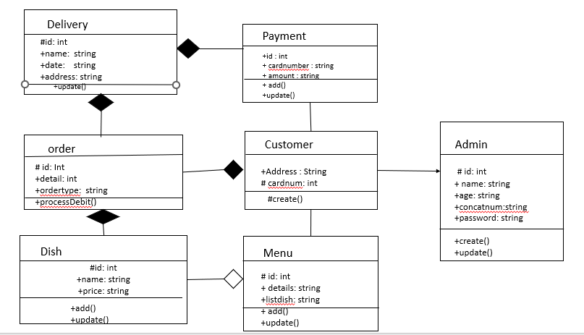

**Fig(3):Class daigram**

**4.4:-ER-daigram**

## A Entity Relationship Diagram showing Food Ordering System. Ideal for restaurant chains who delivery food. You can edit this Entity Relationship Diagram using Creately diagramming.

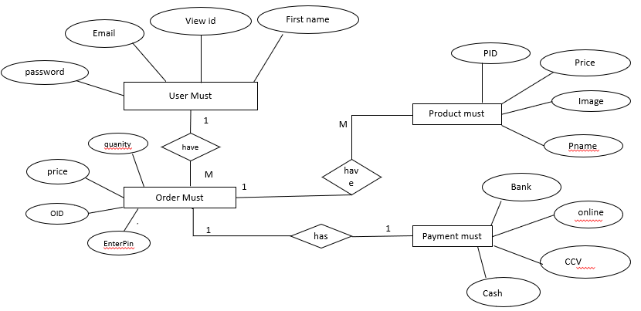

**Fig(4):ER-Daigram**

**4.5:Data Level flow diagram:-**

data flow diagram (DFD) is a graphical model the show all of the main requirement For an information system in a diagram : input and output, process, and data storage. A DFD

Describe what data flows rather than how it is processed. Everyone working on a development project can see all aspects of the system working

Together at once with DFD. That is one of the reason for its popularity, the DFD is also easy To read because it is graphical model. The DFD is mainly used during problem analysis. End

DFD with minimal training.

**4.5.1 DFD Symbol**

1. Process
2. Data Flow
3. External Entity
4. Data Store

**1)Level 0:-**

**Level 0 DFD –**  
At this level, the Input and Output of the system are shown. The system is designed and established across the world with input and output at this level.

1. Food Ordering System has the following input :
   * Food order is input as the customer’s order for food.

Food Ordering System has the following output:

* + Receipt of the order.
  + For further processing the order, the food order is passed to the kitchen.
  + The restaurant manager gets the report of Bill and Management.

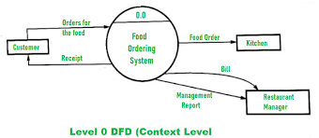

**2)Level 1:**

For processing the order, process 1.0 is responsible. For food, the housekeeping activities involved are represented by processes 2.0, 3.0, and 4.0. The detailed information about daily sold items should be available to create and report management and the list of items that are available ‘in-stock’ should be kept by maintaining the inventory data (describes the records of datasets such as their name, their content, source, many useful information, etc.) at the same time.

Hence, two data stores are used in this level of DFD given below :

* + Database of Sold items
  + Inventory database

In the end, with the use of the amount of daily sold items and daily inventory depletion, it is easy to prepare a report of management. Further, the restaurant manager gets this report of management.

**-**

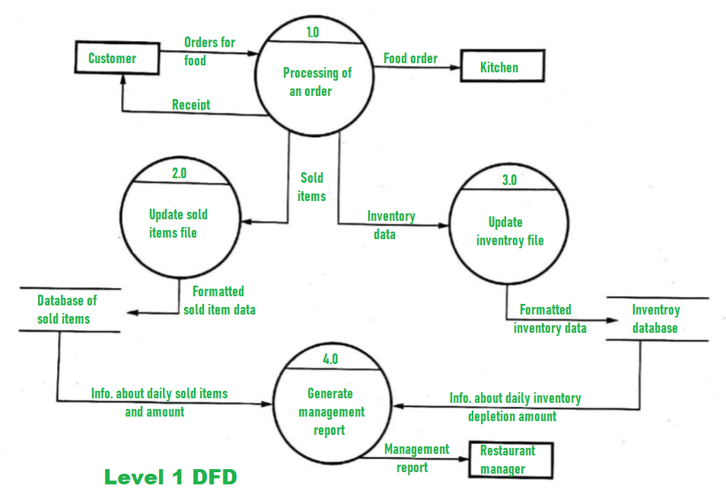

**Level 2:-**

Detailed information about “Processing of an Order” is shown below :

More detailed information about the activity of the “Generate Management Report” is given at this level of DFD. Having access to data of sold items and data of inventory should be available for generating the report of management. Then, both data of solid items and data of inventory need to be aggregated after which the restaurant manager should get the report of management that is prepared from the above calculations.

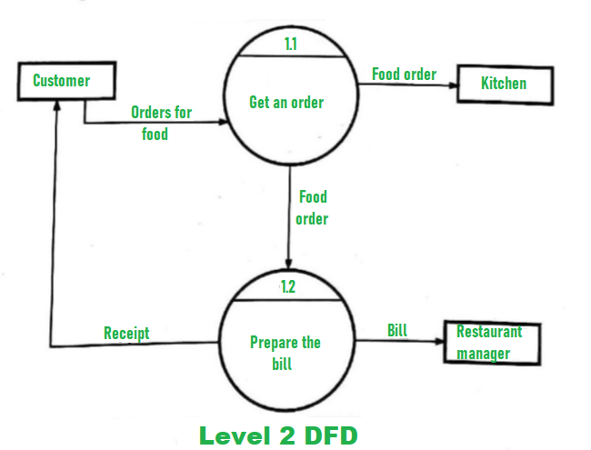

**4.6) Table Structure**

**4.6.1 Login**

Table name: login

Primary key: email id

|  |  |  |
| --- | --- | --- |
| COLOUMN NAME | DATA TYPE | DESCRIPTION |
| EMAIL-ID | TXT | EMAIL-ID |
| PASSWORD | NUMBER | PASSWORD |

4.6.2:**Register-**

Table Name: Register

Primary key: email id

|  |  |  |
| --- | --- | --- |
| COLUMN NAME | DATA TYPE | DESCRPITION |
| FIRST NAME | TXT | FIRST NAME |
| LAST NAME | TXT | LAST NAME |
| EMAIL-ID | TXT | EMAIL-ID |
| CONFRIM PASSWORD | NUMBER | CONFRIM PASSWORD |

**4.6.3Contact us**

Table Name: Contact us

Primary key: email id

Foreign Key: Comment box

|  |  |  |
| --- | --- | --- |
| COLUMN NAME | DATA TYPE | DESCRPTION |
| FIRST NAME | TXT | FRST NAME |
| LAST NAME | TXT | LAST NAME |
| PIN | NUMBER | PIN |
| PHONE NUMBER | NUMBER | PHONE NUMBER |
| LOCATION | TXT | LOCATION |

## **5.IMPLEMNETION**

#### 5.1:MODULES

In this website I have created the online food deliver to customer. And that is name is Zomato Online Food.

In website I have to include home, about us, course etc….

Home

Contanct Us

Delivery

Location

Self pickup

Paymanet mode

Zomato member

Check prices.

#### 5.2:(FRONTEND) WEBPAGE

I have used HTML , CSS , JAVASCRIPT to develop the frontend design

##### 5.3:HTML

(Hypertext Markup Language)

HTML stands for HyperText Markup Language. It is used to design web pages using a markup language. HTML is the combination of Hypertext and Markup language.

Hypertext defines the link between web pages. A markup language is used to define the text document within the tag which defines the structure of web pages.

This language is used to annotate (make notes for the computer) text so that a machine can understand it and manipulate text accordingly.

Most markup languages (e.g. HTML) are human-readable. The language uses tags to define what manipulation has to be done on the text.

##### 5.3:HTML page structure:

The basic structure of an HTML page is laid out below. It contains the essential building-block elements (i.e. doctype declaration, HTML, head, title, and body elements) upon which all web pages are created.

**5.4:CSS( Cascading Style Sheet )**

**C**ascading **S**tyle **S**heets, fondly referred to as CSS, is a simply designed language intended to simplify the process of making web pages presentable.

CSS allows you to apply styles to web pages. More importantly, CSS enables you to do this independent of the HTML that makes up each web page.

It describes how a webpage should look: it prescribes colors, fonts, spacing, and much more. In short, you can make your website look however you want.

CSS lets developers and designers define how it behaves, including how elements are positioned in the browser.

While html uses tags, css uses rulesets. CSS is easy to learn and understand, but it provides powerful control over the presentation of an HTML document.

* + **CSS saves time:** You can write CSS once and reuse the same sheet in multiple HTML pages.

change the style, and all elements in all the webpages will be updated automatically.

* + Search Engines:CSS is considered a clean coding technique, which means search engines won’t have to struggle to “read” its content.
  + Superior styles to HTML:CSS has a much wider array of attributes than HTML, so you can give a far better look to

your HTML page in comparison to HTML attributes.

* + Offline Browsing:CSS can store web applications locally with the help of an offline cache. Using this we can view

offline website.

change the style, and all elements in all the webpages will be updated automatically.

* + Search Engines:CSS is considered a clean coding technique, which means search engines won’t have to struggle to “read” its content.
  + Superior styles to HTML:CSS has a much wider array of attributes than HTML, so you can give a far better look to

your HTML page in comparison to HTML attributes.

* + Offline Browsing:CSS can store web applications locally with the help of an offline cache. Using this we can view

offline website.

##### 5.5:JAVASCRIPT

JavaScriptis a lightweight, cross-platform, and interpreted compiled programming language which is also known as the scripting language for webpages.

It is well-known for the development of web pages, many non-

browser environments also use it.

JavaScript can be used for CLIENT-SIDE developments as well as SERVER_SIDE developments.

Javascript is both imperative and declarative type of language. JavaScript contains

a standard library of objects, like array, date and math, and a core set of language

elements like operators, control structures, and statements.

AngularJS is a JavaScript framework. It can be added to an HTML page with a <script> tag.

AngularJS extends HTML attributes with Directives, and binds data to HTML with Expressions.

AngularJS is a JavaScript Framework

AngularJS is a JavaScript framework written in JavaScript.

AngularJS is distributed as a JavaScript file, and can be added to a web page with a script tag:

<script src="https://ajax.googleapis.com/ajax/libs/angularjs/1.6.9/angu lar.min.js"></script>

AngularJS is a JavaScript framework. It can be added to an HTML page with a <script> tag.

AngularJS extends HTML attributes with Directives, and binds data to HTML with Expressions.

AngularJS Extends HTML

AngularJS extends HTML with ng-directives.

The ng-app directive defines an AngularJS application.

The ng-model directive binds the value of HTML controls (input, select, textarea) to application data.

**5.2.7 Server-side:**

It supplies objects relevant to running JavaScript on a server. Like if the server-side extensions allow an application to communicate with a database, it provide continuity of information from one invocation to another of the application, or perform file manipulations on a server.

**5.2.8 Imperative language –**

In this type of language we are mostly concern about how it is to be done . It simply control the flow of computation . The procedural programming approach , object, oriented approach comes under this like async await we are thinking what it is to be done further after async call.

**5.2.9 Declarative programming-** In this type of language we are concern about how it is to be done basically here logical computation require .Here  main goal is to describe the desired result without direct dictation on how to get it like  arrow function do .

**5.6:CODING:**

<!DOCTYPE html>

<html>

<head>

<meta name="viewport" content="width=device-width, initial-scale=1">

<meta name="viewport" content="width=device-width,intial-scale=1:0">

<link rel="stylesheet" href="s.css">

<link rel="stylesheet" href="https://unpkg.com/swiper@7/swiper-bundle.min.css" />

<style>

div.scrollmenu {

background-color: #333;

overflow: auto;

white-space: nowrap;

}

div.scrollmenu a {

display: inline-block;

color: white;

text-align: center;

padding: 14px;

text-decoration: none;

font-family: cursive;

}

div.scrollmenu a:hover {

background-color: #777;

}

</style>

<style>

h1 {

background-color: yellow;

text-align: center;

font-size: 50;

}

</style>

<style>

img {

border-radius: 10px;

}

</style>

<style>

body {

background-image: url("z2.jpg");

}

</style>

<style>

.swiper{

width: 70%;

height: fit-content;

}

.swiper-slide img{

width: 70%;

padding-top: 30px;

padding-right: 150px;

padding-bottom: 50px;

padding-left: 80px;

}

.swiper .swiper-button-prev, .swiper .swiper-button-next{

color: #fff;

}

.swiper .swiper-pagination-bullet-active{

background: #fff;

}

</style>

<style>

a{

color:red;

font-size: large;

font-size: 150%;

</style>

<style>

span {

background-color: #0AFFFF;

}

</style>

</head>

<body>

<h1 style="color: deeppink">Order food Online On Zomato</h1>

<img src="z1.jpg" alt="i" width="150" height="150">

<div class="scrollmenu">

<a href="#home">Home</a>

<a href="#news">Delivery</a>

<a href="#contact">Contact us</a>

<a href="#about">self pick up</a>

<a href="#support">zomato disc.</a>

<a href="#blog">night life</a>

<a href="#tools">location</a>

<a href="#base">payment mode</a>

<a href="#custom">zomato membership</a>

<a href="#more">log in</a>

<a href="#logo">blogs</a>

<a href="#friends">rating</a>

<a href="#partners">dinning out</a>

<a href="#people">Review</a>

<a href="#Map">Map</a>

</div><br><br>

<div class="swiper">

<!-- Additional required wrapper -->

<div class="swiper-wrapper">

<div

class="swiper-slide">

<img src="C:\Users\Rijwana\OneDrive\Documents\zomato\i1.jpg">

</div>

<div

class="swiper-slide">

<img src="C:\Users\Rijwana\OneDrive\Documents\zomato\b.jpg">

</div>

<div

class="swiper-slide">

<img src="C:\Users\Rijwana\OneDrive\Documents\zomato\d2.jpg"></div>

<div

class="swiper-slide">

<img src="C:\Users\Rijwana\OneDrive\Documents\zomato\e5.jpg"></div>

<div

class="swiper-slide">

<img src="C:\Users\Rijwana\OneDrive\Documents\zomato\j2.jpg"></div>

</div>

<!-- If we need pagination -->

<div class="swiper-pagination"></div>

<!-- If we need navigation buttons -->

<div class="swiper-button-prev"></div>

<div class="swiper-button-next"></div>

</div>

</div>

<script src="https://unpkg.com/swiper@7/swiper-bundle.min.js"></script>

<script>

const swiper = new Swiper('.swiper', {

autoplay: {

delay: 3000,

dsiplayOnInteraction: false,

},

loop: true,

pagination: {

el: '.swiper-pagination',

clickable: true,

},

navigation: {

nextEl: '.swiper-button-next',

prevEl: '.swiper-button-prev',

},

});

</script>

<h2 style="color: red;"><span><a href="t.html">Check Prices</a></span></h2>

<h3 style="color:lime;"><span><a href="l.html">Zomato

Contact us </a></span></h3>

<script src="https://ajax.googleapis.com/ajax/libs/angularjs/1.6.9/

angular.min.js"></script>

<scriptsrc="https://ajax.googleapis.com/ajax/libs/angularjs/1.6.9

/angular-animate.js"></script>

<body ng-app="ngAnimate">

<h1 style="color:palevioletred">Give Review on Yes then

click on it: <input type="checkbox" ng-model="myCheck"></h1>

<div ng-hide="myCheck">

<h1 style="color: blue;">Save it-Yes</h1></div>

</body>

</HTML>

## 

## 

## **6.7:SYSTEM OUTPUT**

**5.7.1:Output in the From of Figure:-**

**5.7.2:HOME Page**

In my online ordering food I have created lots of pages like home,

Delivery, contact us etc.

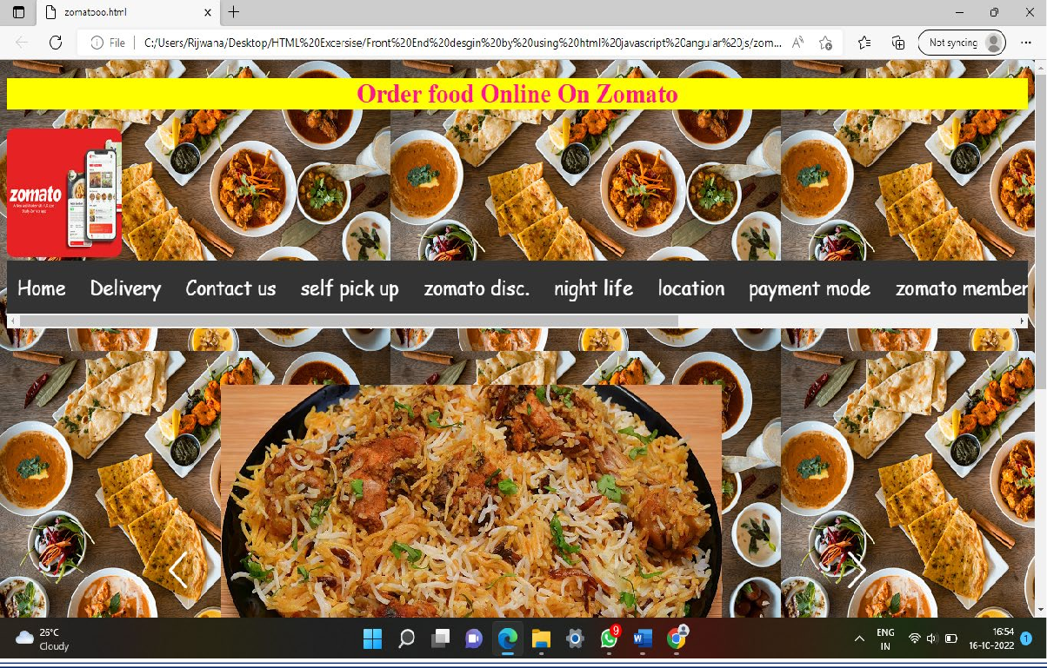

**Figure(1)**

**5.7.3:Check price for dishes :-**

I have created one another Module that is dishes name and their

prices for dishes.

Whatever you want a dish you check the price and give it.



**Figure(2)**

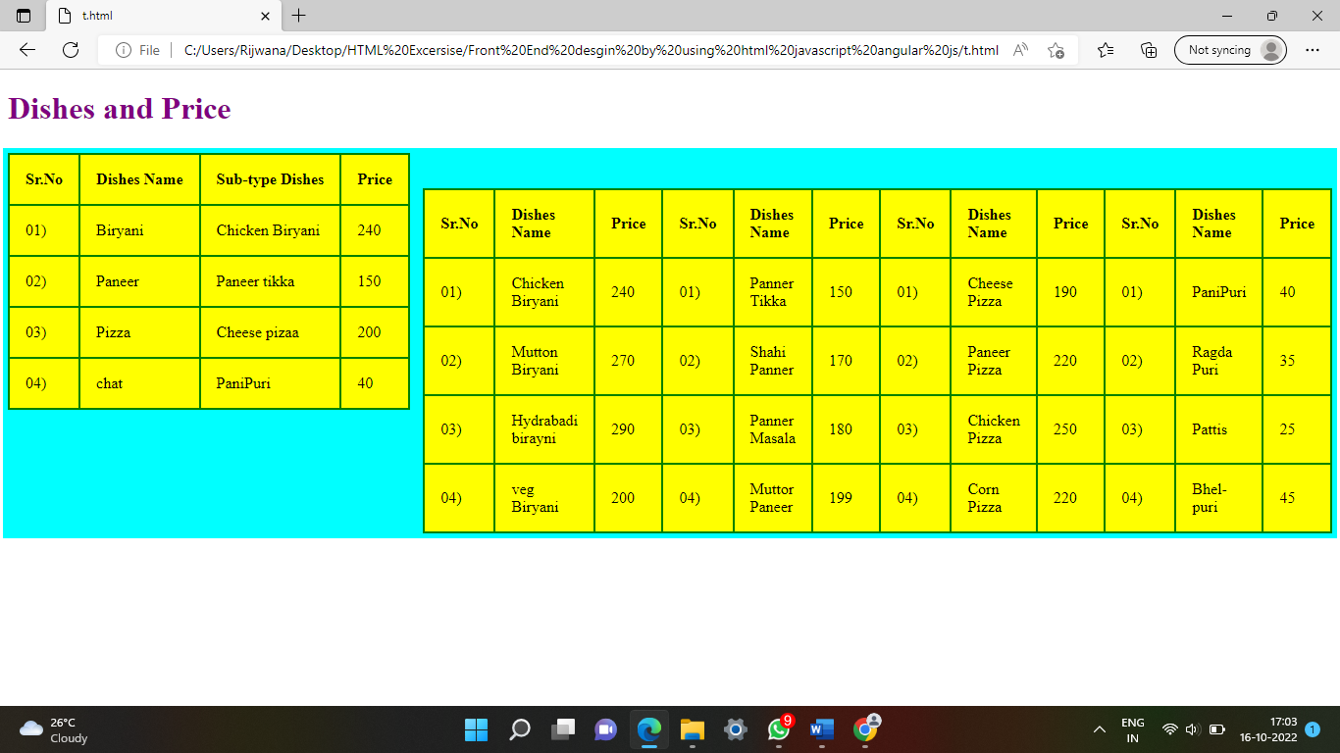

**Figure(3)**

**5.7.4:Give review**

I have created one another module that is Give review on App.

you just click the given checkbox and then its automatiucally send to

give fededback as rating wise.

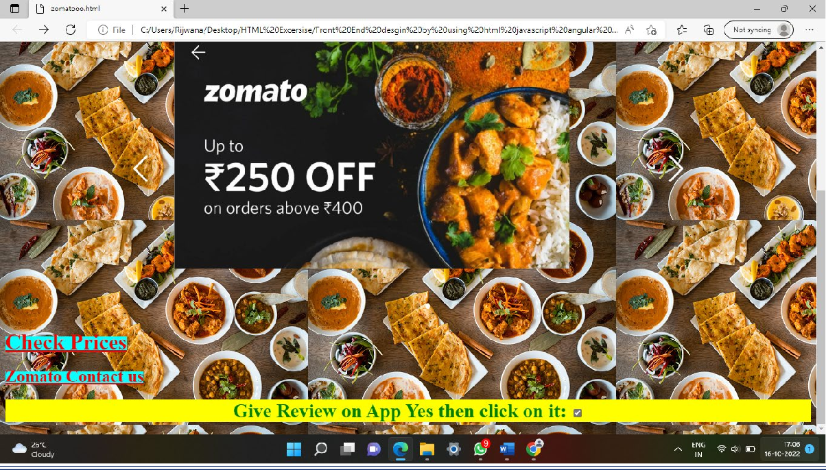

**Figure(4)**

**5.7.5:Zomato contact Us page:**

I have Created one another module like Zomato Contact us Page.

In this Page I have created all customer details information like

Names,Conatact Num,Pin,Address etc….

If the customer has any problems then,we will slove it through.

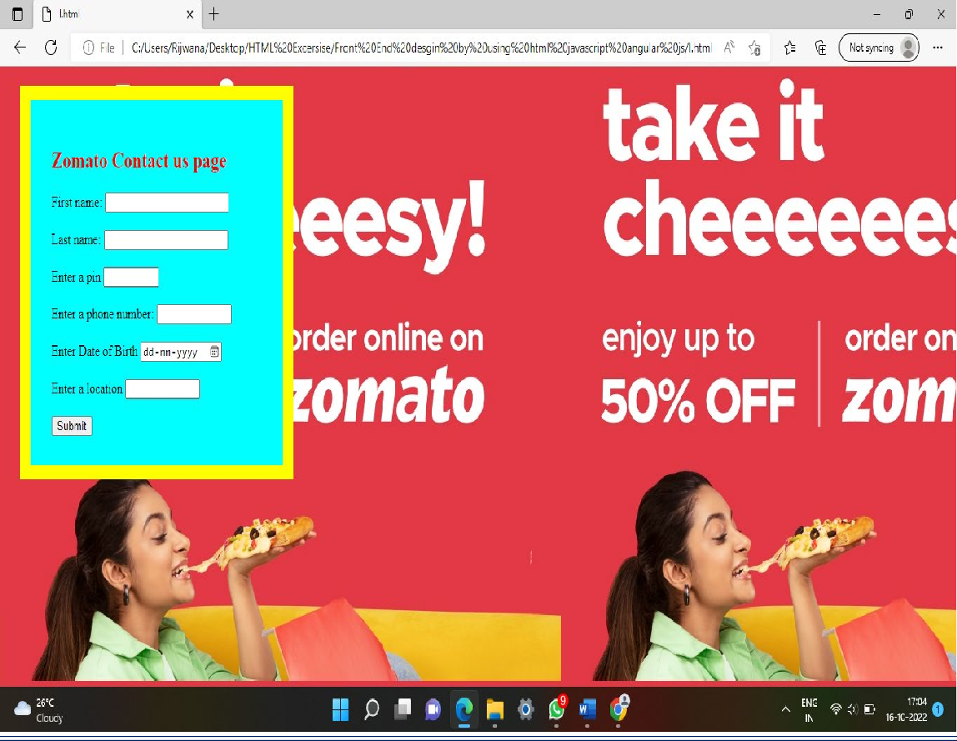

**Figure(5)**

**6.SYSTEM TESTING:**

**6.1 Selenium**

Selenium is one of the most widely used open source Web UI (User Interface) automation testing suite. It was originally developed by Jason Huggins in 2004 as an internal tool at Thought Works. Selenium supports automation across different browsers, platforms and programming languages. Selenium can be easily deployed on platforms such as Windows, Linux, Solaris and Macintosh. Moreover, it supports OS (Operating System) for mobile applications like iOS, windows mobile and android. Selenium supports a variety of programming languages through the use of drivers specific to each language.

Languages supported by Selenium include **C#, Java, Perl, PHP, Python** and **Ruby.** Currently, Selenium Web driver is most popular with Java and C#. Selenium test scripts can be coded in any of the supported programming languages and can be run directly in most modern web browsers. Browsers supported by Selenium include **Internet Explorer, Mozilla Firefox, Google Chrome** and **Safari.**

Selenium Suite

Selenium Gird

Selenium WebDriver

Selenium RC

Selenium IDE

Selenium can be used to automate functional tests and can be integrated with automation test tools such as **Maven**, **Jenkins**, **& Docker** to achieve continuous testing.

It can also be integrated with tools such as **TestNG**, & **JUnit** for managing test cases and generating reports.

**6.2:Testing**

**System Testing** is a level of testing that validates the complete and fully integrated software product. The purpose of a system test is to evaluate the end-to-end system specifications.

Usually, the software is only one element of a larger computer-based system. Ultimately, the software is interfaced with other software/hardware systems.

System Testing is defined as a series of different tests whose sole purpose is to exercise the full computer-based system.

Two Category of Software Testing

* Black Box Testing
* White Box Testing

System test falls under the **black box testing** category of software testing.

**White box testing** is the testing of the internal workings or code of a software application. In contrast, black box or System Testing is the opposte. System test involves the external workings of the software from the user’s perspective

.

**6.2 1 Testing Methodologies**

Software Testing Methodology is defined as strategies and testing types used to certify that the Application under Test meets client expectations.

Test Methodologies include functional and non-functional testing to validate the AUT. Examples of Testing Methodologies are [**Unit Testing**](https://www.guru99.com/unit-testing-guide.html)**,**[**Integration Testing**](https://www.guru99.com/integration-testing.html)**,**[**System Testing**](https://www.guru99.com/system-testing.html)**,**[**Performance Testing**](https://www.guru99.com/performance-testing.html) etc.

Each testing methodology has a defined test objective, test strategy, and deliverables. There are tons of methodologies available for software development and its corresponding testing. Each testing technique and methodology is designed for a specific purpose and has its relative merits and demerits.

Selection of a particular methodology depends on many factors such as the **nature of a project, client requirement, project schedule,** etc.

From a testing perspective, some methodologies push for testing input early in the development life cycle, while others wait until a working model of the system is ready.

**6.2. 2 Equivalence Partitioning**

Equivalence classes are evaluated for given input conditions. Whenever any input is given, then type of input condition is checked, then for this input conditions, Equivalence class represents or describes set of valid or invalid states.

Let us consider an example of any college admission process. There is a college that gives admissions to students based upon their percentage. Consider percentage field that will accept percentage only between 50 to 90 %, more and even less than not be accepted, and application will redirect user to an error page.

This technique tries to define test cases that uncover classes of errors, thereby reducing the total number of test cases that must be developed. An advantage of this approach is reduction in the time required for testing software due to lesser number of test cases.

Equivalence partitioning is typically applied to the inputs of a tested component, but may be applied to the outputs in rare cases. The equivalence partitions are usually derived from the requirements specification for input attributes that influence the processing of the test object.

**6.2.3 Software level testing can be majorly classified into 4 levels:**

1. **Unit Testing:** A level of the software testing process where individual units/components of a software/system are tested. The purpose is to validate that each unit of the software performs as designed.

2. **Integration Testing:** A level of the software testing process where individual units are combined and tested as a group. The purpose of this level of testing is to expose faults in the interaction between integrated units.

3. **System Testing:** A level of the software testing process where a complete, integrated system/software is tested. The purpose of this test is to evaluate the system’s compliance with the specified requirements.

4. **Acceptance Testing:** A level of the software testing process where a system is tested for acceptability. The purpose of this test is to evaluate the system’s compliance with the business requirements and assess whether it is acceptable for delivery.

**6.3:Test case report**

**Test case for Order Online food**

**Project Name:- Order online on Zomatoo**

**Refrence: Project on Food Ordering Sytemt**

**\Created By:-http://www.zomatofood.com team**

**Date of Created:- 02 Oct 2022**

**Date of Created :-19 jan 2023**

Date of review: 19-January -2023.

|  |  |  |  |  |  |  |  |
| --- | --- | --- | --- | --- | --- | --- | --- |
| **Test Scenario 001-Login** | | | | | | | |
| **Test case** | **Test Objective** | **Precon**  **dition** | **Step:** | **Test data** | **Expected result** | **Post Condition** | **Result** |
| 001 |  | A valid account to login | Email id:  password:  click login button. | rijwanas814@gmail.com | Logged successfully | Login  Inbox  Is shown | pass |
| **Test Scenario 002-Register** | | | | | | | |
| 002 |  | A valid account to login | First name:  Last name:  Email id:  Password  Click register  Button. | rijwanas814@gmail.com | Registered successfully | registered inbox is shown | pass |
| **Test Scenario 003-Contact Us** | | | | | | | |
| 003 |  | All details | Enter name: | Rijwana | Contact us  suceefully | Information’s are shown | pass |
| Enter Last name: | Shaikh | Contact us  suceefully | Information’s are shown | pass |
| Enter pin: | 412103 | Contact us  suceefully | Information’s are shown | pass |
| Enter Phone Number:  Enter Birthdate:  Enter Location: | 983437009  28.10.1997  Pune | Contact us  suceefully | Succesfully Info send. | pass |

**6.4 Website Automation Testing Using Selenium**

**Automation Testing** is a software testing technique that performs using special automated testing software tools to execute a test case suite.

On the contrary, Manual Testing is performed by a human sitting in front of a computer carefully executing the test steps.

The automation testing software can also enter test data into the System Under Test, compare expected and actual results and generate detailed test reports.

Software Test Automation demands considerable investments of money and resources.

**6.4.1 Automation testing process:**

Following steps are followed in an Automation Process

**Step 1.** Test Tool Selection

**Step 2.** Define scope of Automation

**Step 3.** Planning, Design and Development

**Step 4.** Test Execution

**Step 5.** Maintenance

**6.4.2 Selenium Automation**

Selenium is a free, open-source automation testing suite for web applications across different browsers and platforms.

It is somewhat similar to HP Quick Test Pro (QTP, currently UFT). However, Selenium focuses on automating web-based applications.

Testing done using Selenium is usually referred to as Selenium testing. Remember, only testing web applications is possible with Selenium. You cannot use it to test desktop applications or mobile applications.

I have created an website for online courses named as CareerBridge And I have done test Automation on my project by using selenium and the syntax for testing my website is

**6.5 Selenium code for Career bridge:**

package sele2;

import org.openqa.selenium.By;

import org.openqa.selenium.WebElement;

import org.openqa.selenium.WebDriver;

import org.openqa.selenium.chrome.ChromeDriver;

public class DiffrentWaysToXpath {

public static void main(String[] args) throws InterruptedException {

System.setProperty("webdriver.chrome.driver", "C:\\Users\\Rijwana\\Desktop\\rijwana\\chromedriver_win32\\chromedriver.exe");

WebDriver driver=new ChromeDriver();

driver.get("file:///C:/Users/Rijwana/OneDrive/Documents/zomato/z.html");

driver.findElement(By.*partialLinkText*("Check Prices")).click();

driver.findElement(By.partialLinkText("Zomato Contact us")).click();

driver.findElement(By.xpath("//*[@id=\"fname\"]")).sendKeys("Rijwana");

driver.findElement(By.xpath("//*[@id=\"lname\"]")).sendKeys("Shaikh");

driver.findElement(By.xpath("//*[@id=\"pin\"]")).sendKeys("412103");

driver.findElement(By.xpath("//*[@id=\"phone num\"]")).sendKeys("9834377006");

driver.findElement(By.xpath("//*[@id=\"Date\"]")).sendKeys("28-10-1997");

driver.findElement(By.xpath("//*[@id=\"Tadd\"]")).sendKeys("Pune");

driver.findElement(By.xpath("//*[@type=\"submit\"]")).click();

driver.quit();

}

}

**6.6:OUTPUT**

**6.6.1:Home page**

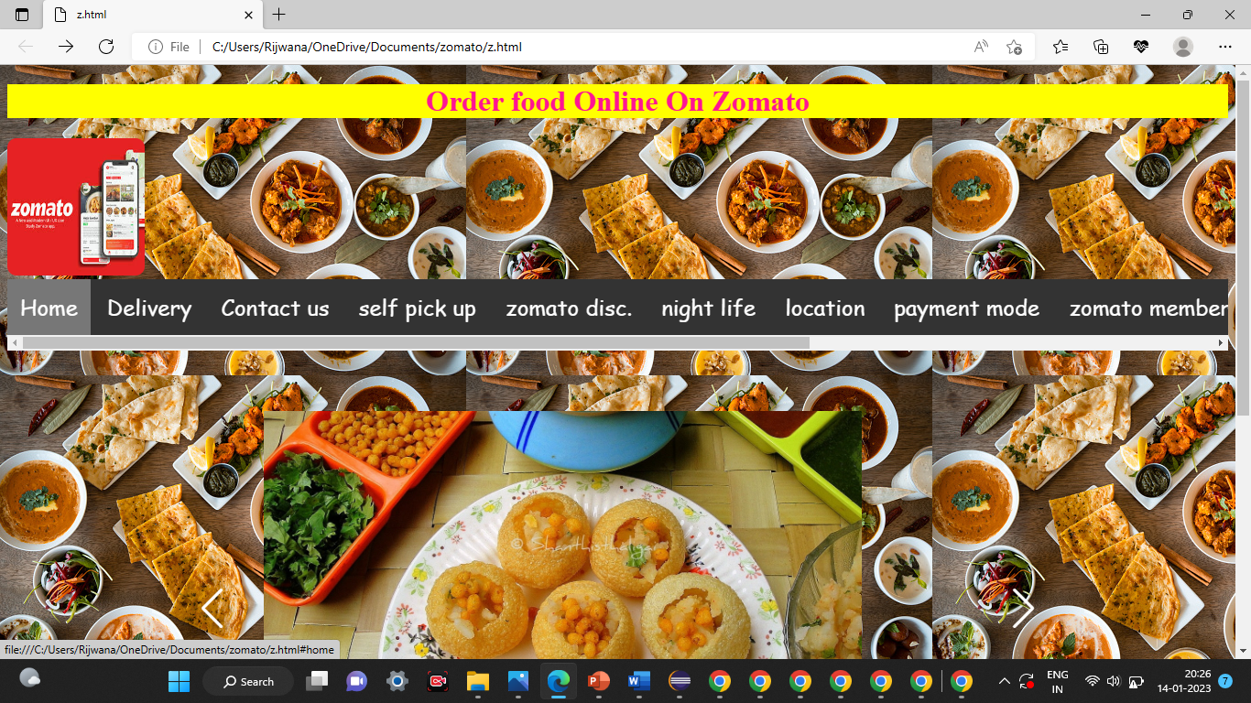

In above figure we can see the home page

**6.6.2:Check prices:**

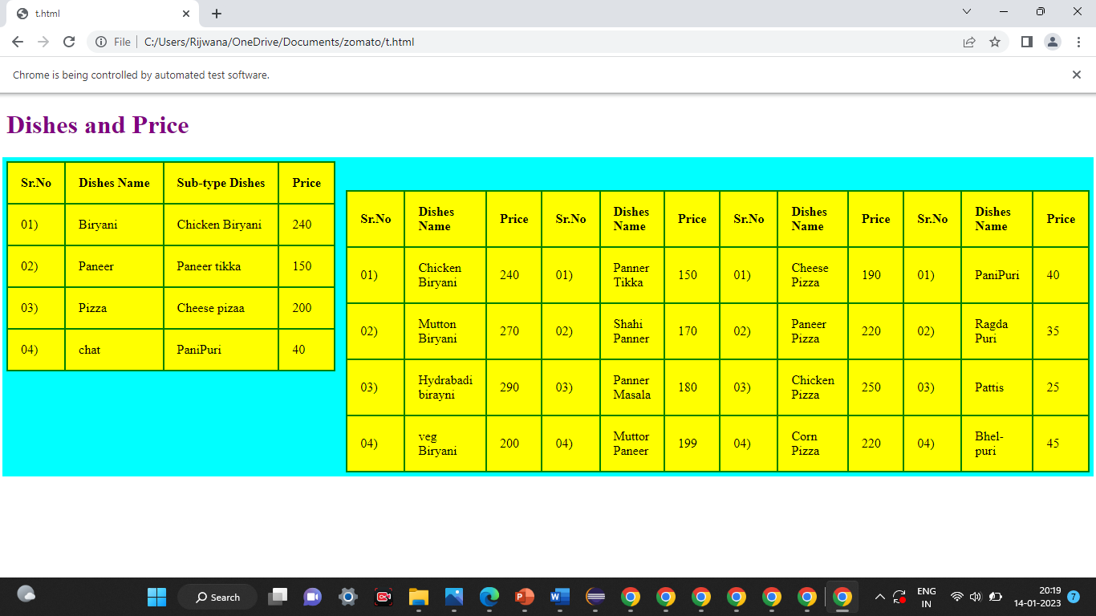

In above figure we see the check Price for dishes.

**6.6.3:Zomato contact us page:**

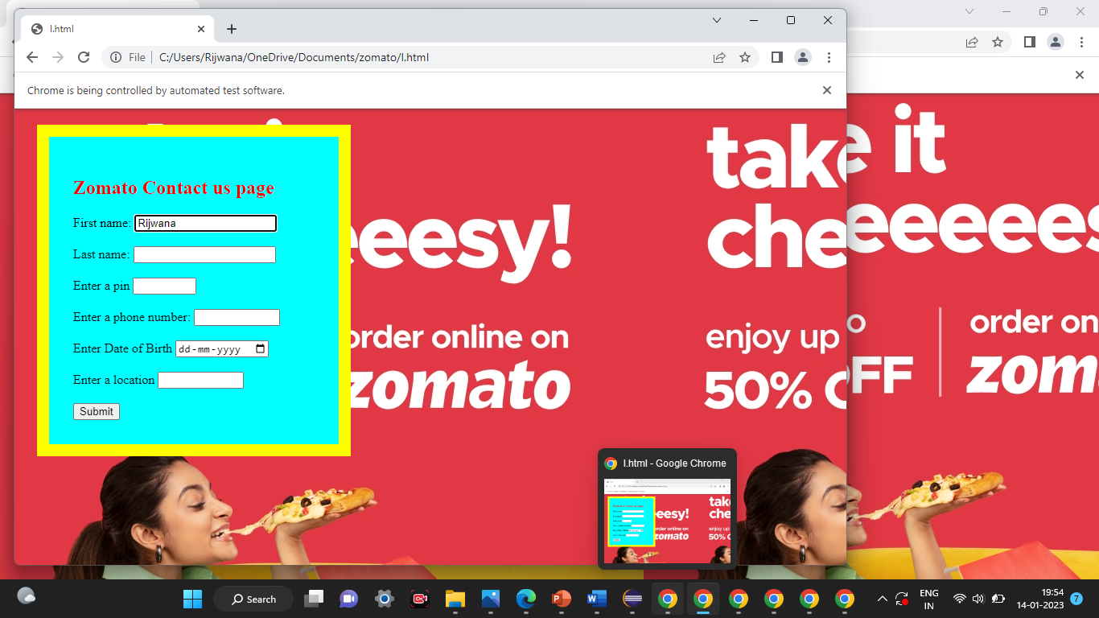

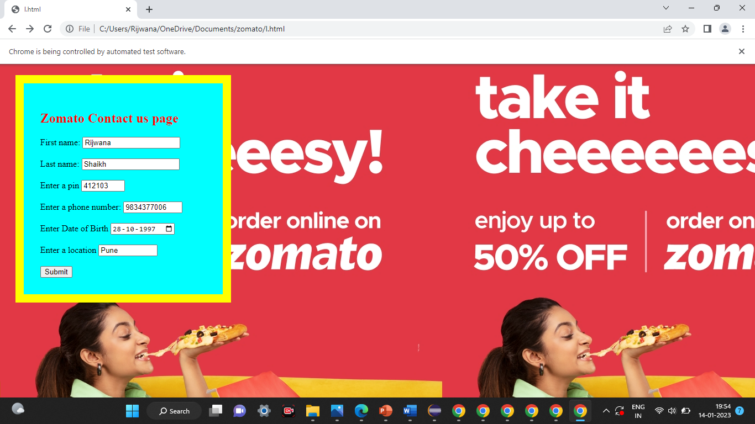

In the Above fig we see the Zomato contact us page and we fill the infomartion about

Our self contact.and we create a database store in information data base sql.we see

the below.

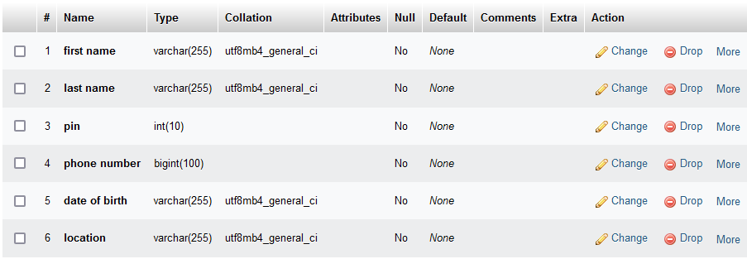

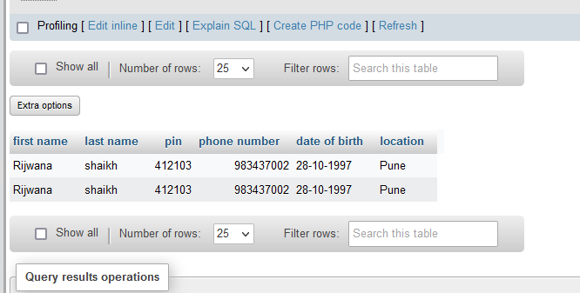

In this above sample contact us page output the browser enter the details like first name, last name, pin,phone num,date of birth,location and the main option is comment line that is mandatory to fill after filling all the details the browser click the send button. And the contact form send successfully.we succefully give our food.

This is the whole process have done by selenium Automation testing done.

**6.7 Automation testing for Great Learning website**

**package** sele2;

**import** org.openqa.selenium.By;

**import** org.openqa.selenium.WebDriver;

**import** org.openqa.selenium.WebElement;

**import** org.openqa.selenium.chrome.ChromeDriver;

**import** org.testng.Assert;

**import** org.testng.annotations.Test;

**public** **class** abc {

@Test

**public** **void** login() {

System.*setProperty*("webdriver.chrome.driver",

"C:\\Users\\Rijwana\\Desktop\\rijwana\\chromedriver_win32\\chromedriver.exe");

WebDriver driver=**new** ChromeDriver();

driver.manage().window().maximize();

driver.get("https://www.browserstack.com/users/sign_in");

driver.findElement(By.*id*("user_email_login")).sendKeys("shaikhadam177@gmail.com");

driver.findElement(By.*id*("user_password")).sendKeys("Sspm123***");

driver.findElement(By.*xpath*("//*[@value=\"Sign me in\"]")).click();

WebElement username=driver.findElement(By.*id*("user_email_Login"));

WebElement password=driver.findElement(By.*id*("user_password"));

WebElement login=driver.findElement(By.*name*("commit"));

username.sendKeys("abc@gmail.com");

password.sendKeys("your_password");

login.click();

String actualUrl="https://live.browserstack.com/dashboard";

String expectedUrl= driver.getCurrentUrl();

Assert.*assertEquals*(expectedUrl,actualUrl);

}

}

**6.6 Output**

**6.6.1:BrowserStack(sign in):**

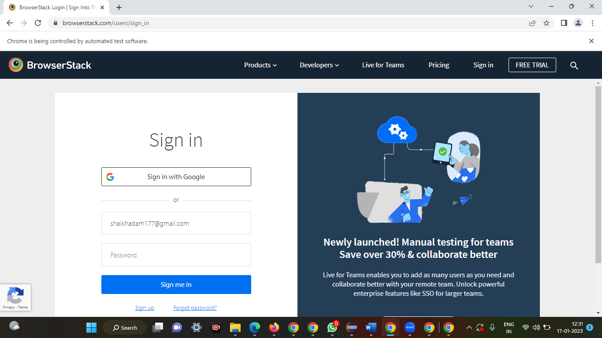

Here I am craeted the page of sign in.

And then I am first created the email address or username page.

And pass value them.

.

**2 Password-**

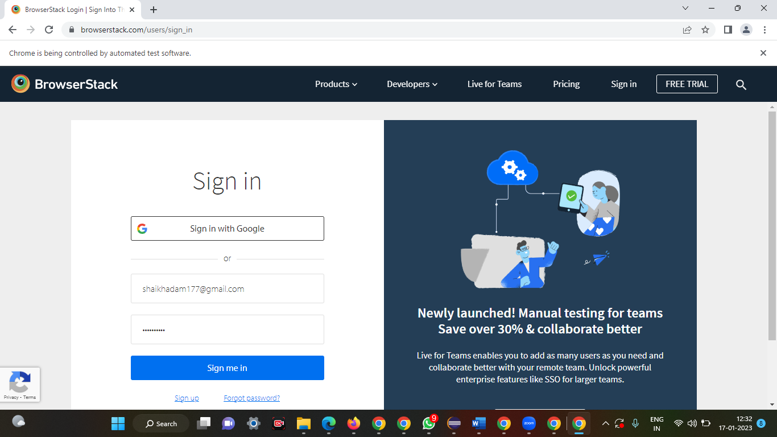

Here I am created password tag and them put the value or send keys them.

**3.Sign in page-**

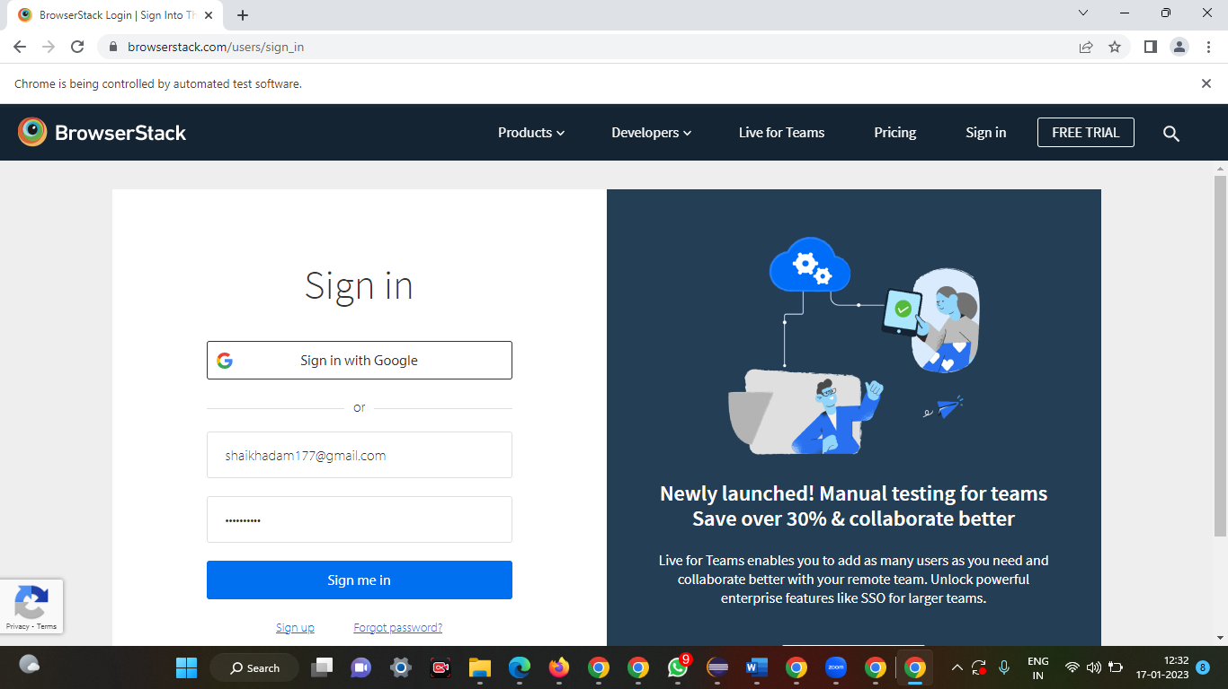

Here I am successfully sign in up with the help

Of some methods.

**4.About website-**

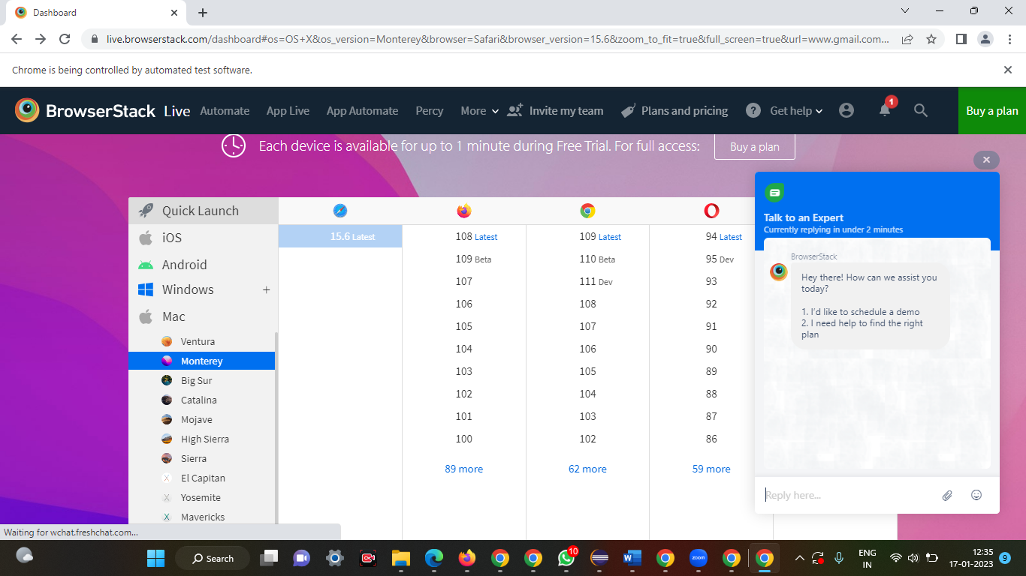

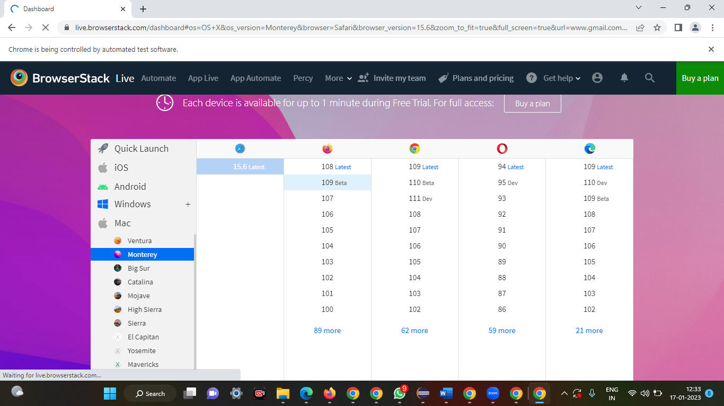

**Fig-Browstack**

**7.CONCLUSION**

**7.1: Project Online Food Ordering System:-**

Our project is only a humble venture to satisfy the needs to manage their project work.Several user friendly coding have also adopted. This package shall prove to be a powerful package in satisfying all the requirements of the school.   
The objective of software planningis to provide a frame work that enables the manger to make reasonable estimates madewithin a limited time frame at the beginning of the software project and should be updatedregularly as the project progresses.At the end it is concluded that we have made effort on following points...

• A description of the background and context of the project and its relation to workalready done in the area.

• Made statement of the aims and objectives of the project.

• The description of Purpose. Scope, and applicability

• We define the problem on which we are working in the project.

• We describe the requirement Specifications of the system and the actions thatcan be done on these things.